South China University of Technology
《Computer Organization and Architecture》Experiment Report
Experiment Title： Serial Adder & Parallel Adder
Name： 谭演锋 Student ID： 202130100456
Class： 计算机全英联合班 Group： None
Collaborator： None
Teacher： 毛爱华
Description
【Objective and Requirement】
Objective：
(1) Understand the structure of serial and parallel adder;
(2) Know the principle and implementation of arithmetic shift register;

Requirement：
Design 4-bit signed serial adder and parallel adder with same inputs, and compare the results of them.

【Environment】
Operating System：Windows XP
Content
【Procedure】
- Step：
Based on previous diagrams and principles, design the whole circuit diagram and verify the correctness.
Start the simulation, Switch SW2 to make 1. Let BUS_[7..4]=0101，BUS_[3..0]=0010(Set the input bits in DSW1)，M=0(switch SW7). Observe the result and compare it between serial and parallel adder, check if it’s overflow. If BUS_[3..0]=0011, what’s the result?
Do the same when
  - BUS_[7..4]=0101，BUS_[3..0]=0011，M=1
  - BUS_[7..4]=0011，BUS_[3..0]=0101，M=1
  - BUS_[7..4]=1101，BUS_[3..0]=0011，M=0
  - BUS_[7..4]=1101，BUS_[3..0]=0011，M=1

2. Data：

3. Major Procedure：
1.Based on previous diagrams and principles, design the whole circuit diagram and verify the correctness.
2.Start the simulation, Switch SW2 to make 0. Let BUS_[7..4]=0101，BUS_[3..0]=0010(Set the input bits in DSW1)，M=0(switch SW7). Observe the result and compare it between serial and parallel adder, check if it’s overflow. If BUS_[3..0]=0011, what’s the result?
Let BUS_[7..4]=0101，BUS_[3..0]=0010, M=0 result is: 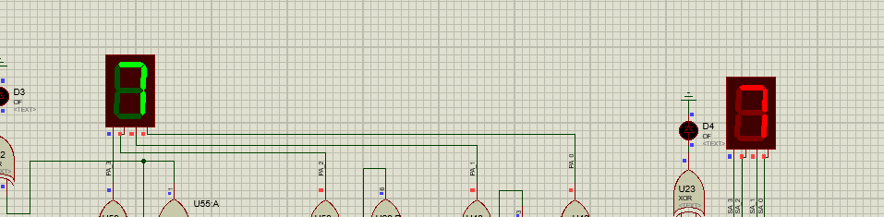
Explainion: BUS_[7..4]=0101=5，BUS_[3..0]=0010=2, M=0 means “+”. Therefore the final resut is equal to 7.
Let BUS_[7..4]=0101，BUS_[3..0]= 0011, M=0 result is:
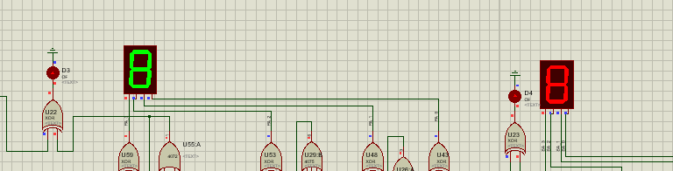
Explainion: BUS_[7..4]=0101=5，BUS_[3..0]= 0011=3, M=0 means “+”. Therefore the final resut is equal to 8. However since we reprens the number in the two’s complement way, the range of the number is [-8,7]. 8>7, which means we have a carry bit so the light of carry bit is flashing.

3. Do the same when
(1)BUS_[7..4]=0101，BUS_[3..0]=0011，M=1
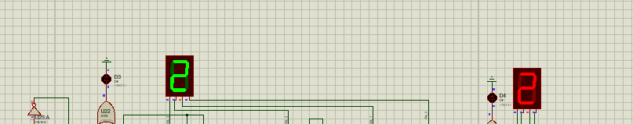
Explainion: BUS_[7..4]=0101=5，BUS_[3..0]=0011=3, M=1 means “-”. Therefore the final resut is equal to “5-3 = 2”.
(2)BUS_[7..4]=0011，BUS_[3..0]=0101，M=1
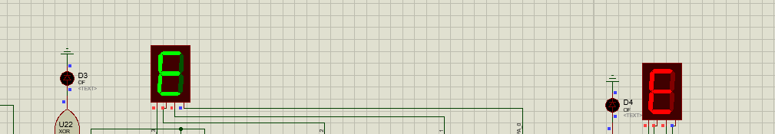
Explainion: BUS_[7..4]=0011=3，BUS_[3..0]=0101=5, M=1 means “-”. Therefore the final resut is equal to 3-5 = -2, which is equl to “1110” in two’s complement. As result, “1110” is equal to 14 in the orginal representation of binay code and which is equal to “E” in heximal representation.
(3)BUS_[7..4]=1101，BUS_[3..0]=0011，M=0
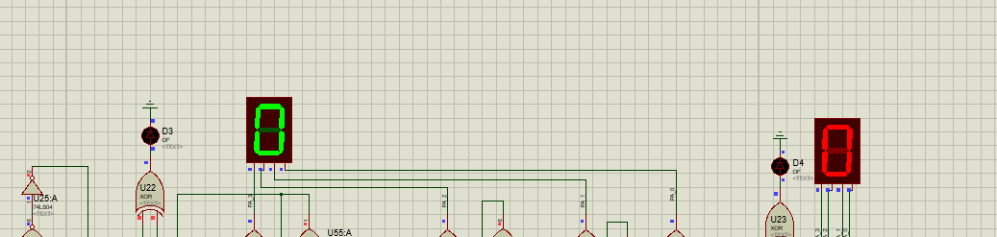
Explainion: BUS_[7..4]=1101=-3，BUS_[3..0]=0011=3, M=0 means “+”. Therefore the final resut is equal to -3+3 = 0.
(4)BUS_[7..4]=1101，BUS_[3..0]=0011，M=1
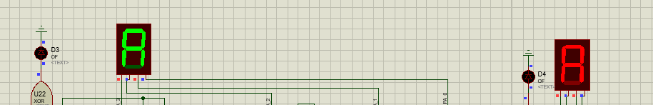
Explainion: BUS_[7..4]=1101=-3，BUS_[3..0]=0011=3, M=0 means “-”. Therefore the final resut is equal to -3-3 = -6, which is equl to “1010” in two’s complement. As result, “1010” is equal to 10 in the orginal representation of binay code and which is equal to “A” in heximal representation.

4.Questions:
1. Is this experimental ALU original form or 2’s complement form? Assume we want to modify the circuit into unsigned 4-bit original form ALU, what we need to do?
In 2’s complement form. We should modify the part of the overflow in the circuit of two adders to achieve the unsigned 4-bit original form ALU. Since no matter the 2’s complement form or the unsigned 4-bit original form the adder just add each bit and sum them together. The computer does not know which form it is. We should change the dectection of the overflow should dectect the 4th bit and the next carry bit to dectect the overflow of 16 intead of 8. Finally we can achieve the
operation for the unsigned 4-bit original form ALU.

2. In this experiment, what’s the range of the 4-bit 2’s complement code? If we want to modify it into 5-bit 2’s complement ALU(1 bit for sign bit, 4 bits for numbers), how does the range change? How to modify it?
The range of the 4-bit 2’s complement code is [-8,7]. If we modify it into 5-bit 2’s complement ALU the range is [-16,15]. The way we modify it is equal to First modify the switcher to 10bits and add a RESPACK-8, 74LS244 LEDS for more bits control. 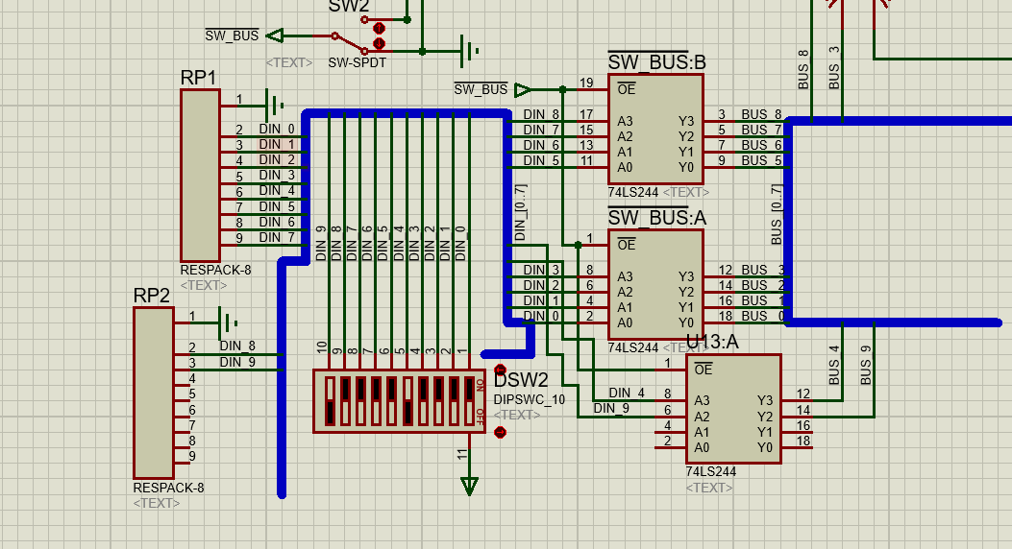 Then modify the circuit, Let BUS_[9..5], BUS_[4..0] to represent two numbers.
For the Serial-Adder: like the picture 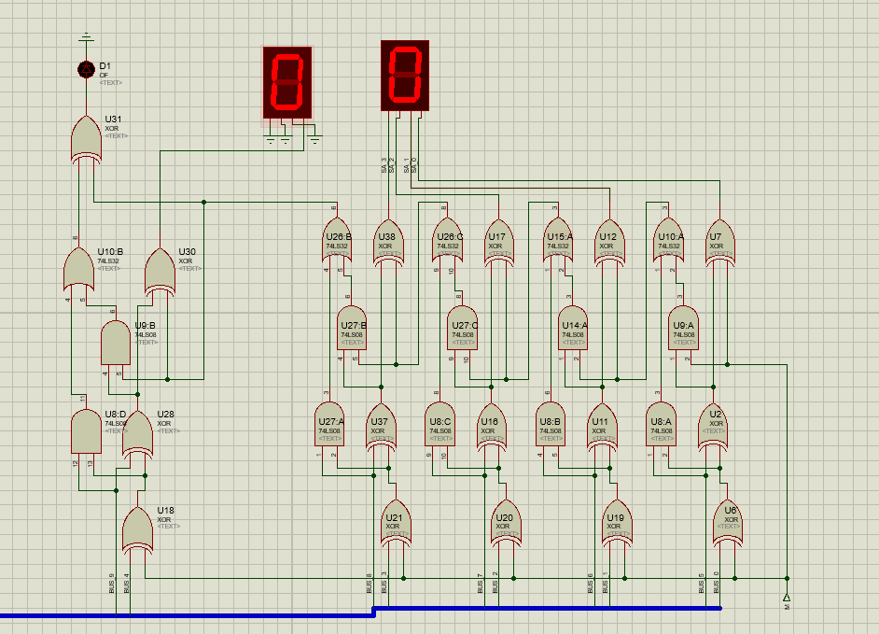
We should add a Full adder to the original circuit to realize the 5 bits adder.
For the Parallel-Adder:
Calculate: C5=Y4+X4C4=Y4+X4Y3 +X4X3Y2+ X4X3X2Y1 +X4X3X2X1Y0 +X4X3X2X1X0C0
Then we can add a C5 circuit with the components of “AND” and ”OR” gates with different pins to construct the circuit to represent the 5th bit of the result.

Conclusion
After the experiment I have a deeply understanding of the accomplishment way of the serial and parallel adder, which are connected in different way. For the serial adder, it adds the least significant bit (LSB) first and then proceeds to the most significant bit (MSB). Each bit addition requires a full adder circuit. The carry-out of each bit addition is fed as the carry-in of the next bit addition. For the parallel adder, it adds all the corresponding bits of the two numbers at the same time, starting from the least significant bit (LSB) to the most significant bit (MSB). Each bit addition can be carried out independently using a full adder circuit. I also learn that in a serial adder, the addition of bits is performed sequentially, one bit at a time, while in a parallel adder, all the bits are added simultaneously.
Teacher’s Comments and Score
Comment：

Score： Signature：
Date：

